Project Interim Report
on
File Compression Simulator
(Using Core Java & OOP Concepts)
RU-100-01-00012
Object Oriented Programming with Java



RUNGTA INTERNATIONAL SKILLS UNIVERSITY
SESSION: 2025-26
Submitted To :

Subject teacher name Submitted By :-
(Shivansh Mehta) Student name:- Aditya Kumar
Ref No :- 2025-01625
Erp ID :- RU-25-10089

RUNGTA INTERNATIONAL SKILLS
UNIVERSITY ,CG
SCHOOL OF COMPUTER SCIENCE ENGINEERING
Student Grading System (OOP Project)
Programming language : JAVA
Subject : Object-Oriented Programming
Object oriented Programming Projects Report

INDEX
SERIAL NO. | TITLE | PAGE NO.
1. | Abstract
2. | Introduction
3. | Scope
4. | System Requirements
5. | Methodology
6. | Flowchart
7. | Implementation
8. | References

Abstract

The Student Grading System is a Java-based application developed using Object-Oriented Programming (OOP) principles to efficiently manage and evaluate student academic performance. The main objective of this project is to automate the process of calculating average marks and assigning grades, thereby reducing manual effort and minimizing errors.

In traditional systems, grading students manually can be time-consuming, inconsistent, and prone to calculation mistakes. This project addresses these issues by providing a structured and automated approach where the user inputs student details such as name and marks, and the system processes this data to generate accurate results.

The system calculates the average marks by summing all subject scores and dividing by the total number of subjects. Based on the calculated average, a grade is assigned using predefined conditions (A, B, C, D, or F). The program then displays the complete student report including name, marks, average, and grade.

This project demonstrates the effective use of OOP concepts such as classes, objects, encapsulation, and methods. It also improves logical thinking and programming skills. The system is simple, efficient, and can be further enhanced by adding features like database storage and graphical user interface.

Introduction

In the modern education system, managing student academic records accurately and efficiently is very important. Educational institutions often deal with large amounts of student data, and manual evaluation of marks can lead to errors, inefficiency, and inconsistency. Therefore, there is a need for an automated system that can simplify and improve the grading process.
The Student Grading System is designed as a console-based Java application that uses Object-Oriented Programming concepts to evaluate student performance. The system allows users to input student details such as name and marks for multiple subjects. It then processes this information to calculate the average marks and assign a grade based on predefined criteria.
This project focuses on applying core OOP concepts such as class creation, object instantiation, encapsulation, and method implementation. The Student class is designed to hold data and perform operations like calculating the average and assigning grades. The use of methods ensures modularity and code reusability, making the system easy to understand and maintain.
- Key Features of the System
- Stores student name and marks securely using encapsulation
- Calculates average marks automatically
- Assigns grades based on standard grading criteria
- Displays complete student performance details
- Simple and user-friendly console interface
- Objectives of the Project
- To automate the student grading process
- To reduce manual calculation errors
- To apply Object-Oriented Programming concepts in a practical scenario
- To develop a structured and maintainable program
- To improve problem-solving and logical thinking skills
Overall, this project provides a basic yet effective solution for managing student grading and serves as a strong foundation for developing more advanced academic management systems in the future.

Scope

The Student Grading System is designed as a basic application to manage and evaluate student academic performance efficiently. The scope of this project mainly focuses on small-scale academic use, where student details and marks can be processed to generate accurate results such as average and grade.
This system is suitable for schools, colleges, and beginners who want to understand how grading systems work using programming concepts. It provides a simple and effective solution for handling student data without requiring complex infrastructure.
The current version of the project is limited to a console-based application and works for a single student at a time. It performs basic operations such as accepting marks, calculating the average, and assigning grades based on predefined conditions. The system does not include advanced features like data storage or multi-user support.
However, the scope of this project can be significantly expanded in the future. Some possible enhancements include:
- Adding support for multiple students
- Integrating a database to store student records permanently
- Developing a graphical user interface (GUI) for better user experience
- Implementing advanced grading systems (percentage, GPA, ranking)
- Adding subject-wise analysis and performance reports
- Creating login systems for teachers and administrators
Overall, this project serves as a foundational model that demonstrates how a real-world student management system can be built and improved using Object-Oriented Programming concepts.

System Requirements

Hardware Requirements

The system requires basic hardware components to run efficiently. Since the project is console-based and lightweight, it does not require high-end specifications.

Computer or Laptop

Minimum 4 GB RAM for smooth execution

Processor: Intel i3 or higher (or equivalent)

Hard Disk: At least 500 MB free space for program storage and execution

Keyboard for input operations

Monitor for displaying output

Software Requirements

The system requires a proper software environment to develop and execute the Java program.

Operating System: Windows, Linux, or macOS

Java Development Kit (JDK) for compiling and running Java programs

Integrated Development Environment (IDE) such as VS Code, Eclipse, or IntelliJ IDEA

Command Prompt or Terminal for program execution

Basic knowledge of Java programming language

Methodology

The methodology of the Student Grading System explains the step-by-step working of the program. It describes how the system processes user input, performs calculations, and generates the final output.

First, the program starts execution from the main method. The user is prompted to enter the student’s name and marks for different subjects using the keyboard. These inputs are then stored in variables and passed to the Student class.

Next, an object of the Student class is created. The constructor is used to initialize the student’s name and marks. This ensures that the data is properly stored inside the object.

After storing the data, the system calculates the average marks using the calculateAverage() method. In this method, all the marks are added together and divided by the total number of subjects to get the average score.

Once the average is calculated, the assignGrade() method is called. This method uses conditional statements (if-else) to assign a grade based on predefined criteria such as A, B, C, D, or F.

Finally, the displayDetails() method is used to show the complete result. It displays the student’s name, marks, average score, and assigned grade on the screen.

The entire process is simple, efficient, and user-friendly. The use of separate methods for each task makes the program modular, easy to understand, and easy to maintain.

Flowchart (Student Grading System)

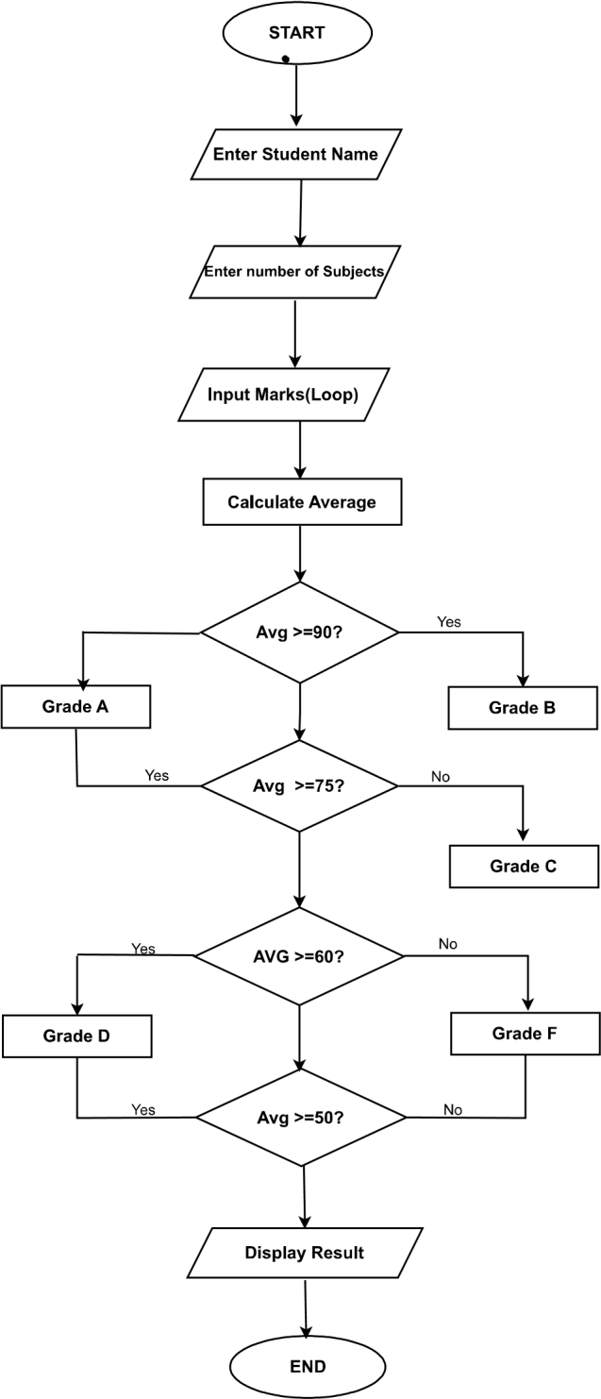

Implementation

The Student Grading System is implemented using Java programming language by applying Object-Oriented Programming (OOP) concepts. The system is divided into different classes and methods to ensure modularity, reusability, and clarity of code.
- Student Class
The Student class is the core part of the system. It is responsible for storing student-related data and performing operations on it.
- It contains private data members such as:
  - name to store the student’s name
  - marks[] to store marks of different subjects
- Encapsulation is achieved by keeping these variables private and accessing them through methods.

- 2. Constructor
A constructor is used to initialize the student’s name and marks at the time of object creation. This ensures that every student object is created with proper data.

- 3. CalculateAverage() Method
This method is used to calculate the average marks of the student.
Logic:
- All marks are added together
- The sum is divided by the total number of subjects
- The result is returned as the average

- 4. AssignGrade() Method
This method assigns a grade based on the calculated average.
Logic:
- Uses if-else conditions
- Checks the range of average marks
- Assigns grade A, B, C, D, or F accordingly

- 5. Displaydetails() Method
This method displays the final result of the student.
It shows:
- Student name
- Marks
- Average marks
- Grade

- 6. Main Class
The Main class controls the execution of the program.
- It takes input from the user using Scanner
- Creates an object of the Student class
- Calls the required methods:
  - calculateAverage()
  - assignGrade()
  - displayDetails()

- Overall Working
- User enters student name and marks
- Student object is created
- Average is calculated
- Grade is assigned
- Final result is displayed

References

Books
[1] H. Schildt, Java: The Complete Reference, 11th ed. New York: McGraw-Hill Education, 2018.
→ This book provides a comprehensive understanding of Java programming concepts including OOP principles, syntax, and real-world applications.
[2] E. Balagurusamy, Programming with Java, 5th ed. New Delhi: McGraw-Hill Education, 2014.
→ This book explains fundamental and advanced Java concepts with practical examples, useful for beginners and students.
[3] K. Arnold and J. Gosling, The Java Programming Language, 4th ed. Boston: Addison-Wesley, 2005.
→ Written by the creators of Java, this book offers deep insights into Java programming and object-oriented design.

Websites
[4] Oracle, “Java Documentation,” Oracle Corporation. [Online]. Available: https://docs.oracle.com
→ Official documentation for Java providing detailed explanations of classes, methods, and libraries.
[5] GeeksforGeeks, “Java Programming Basics,” GeeksforGeeks. [Online]. Available: https://www.geeksforgeeks.org
→ A widely used platform for learning programming concepts, examples, and problem-solving techniques.
[6] TutorialsPoint, “Java Tutorial,” TutorialsPoint. [Online]. Available: https://www.tutorialspoint.com/java
→ Provides step-by-step tutorials and examples for understanding Java programming.

Journal Articles
[7] A. Sharma and R. Gupta, “Machine Learning Techniques,” International Journal of Artificial Intelligence, vol. 5, no. 2, pp. 45–50, 2020.
→ Discusses modern computational techniques and their applications, helpful for understanding system design concepts.

Conference Papers
[8] S. Kumar, “Artificial Intelligence in Education,” in Proceedings of IEEE Conference on Artificial Intelligence, 2021, pp. 120–125.
→ Explores the use of automation and intelligent systems in educational environments.

